

**VILNIUS UNIVERSITY  
SIAULIAI ACADEMY**

BACHELOR PROGRAMME SOFTWARE ENGINEERING

**Individual project of the e-shop “Shimmer and Shine”**

E-services for Business Management Algorithms

Student : Hanna Asiadouskaya

Lecturer: Prof. Dr. Dale Dzemydiene

Siauliai, 2024

Table of Contents

Introduction: 3

Structure of the E-shop 4

Functionality of the E-shop 5

Modelling of the workflow 14

Conclusion 16

Literature 16

# Introduction:

**Topicality of the problem:** The topicality of creating an e-shop aligns with current market trends, consumer behaviour, and technological progress. For businesses, it represents not just an opportunity for growth but a necessity for survival in the competitive digital era.

**Goal:** Develop and Launch E-shop

**Tasks:**

* Planning of the design and idea of the e-shop
* Select the products to sell
* Design logo of the shop
* Construct Class Diagram to display relationship between objects, explain what those objects do and provide
* Construct Activity diagram to show the flow of one activity to another
* Construct BPMN diagrams to model the steps of a planned business process from end to end
* Instal and configure e-shop
* Implement catalog structure by creating categories
* Fill catalog with products of different categories
* Design theme and alignment of the project
* Design and enable registration
* Set up payment methods
* Set up shipment methods
* Configure customers reviews

**Application area:** Verskis.lt

**Methods**: Verskis.lt, draw.io, Lucidchart, payment modules, shipment modules

# Structure of the E-shop

**Idea of the e-shop:** A workshop, creating hand-crafted utensils, like plats, bowls, cups and mugs from clay, metal, and glass.

**Name:** Shimmer and Shine

**Link:** <https://shimmerandshine-gmail.manoverskis.lt/>

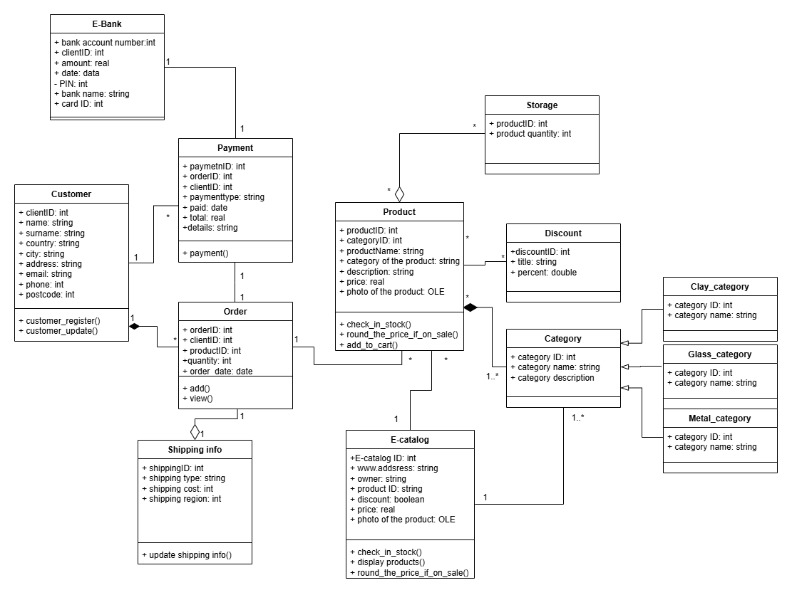

# Functionality of the E-shop

Implemented functions from programming aspect:

* Product Catalog:



* 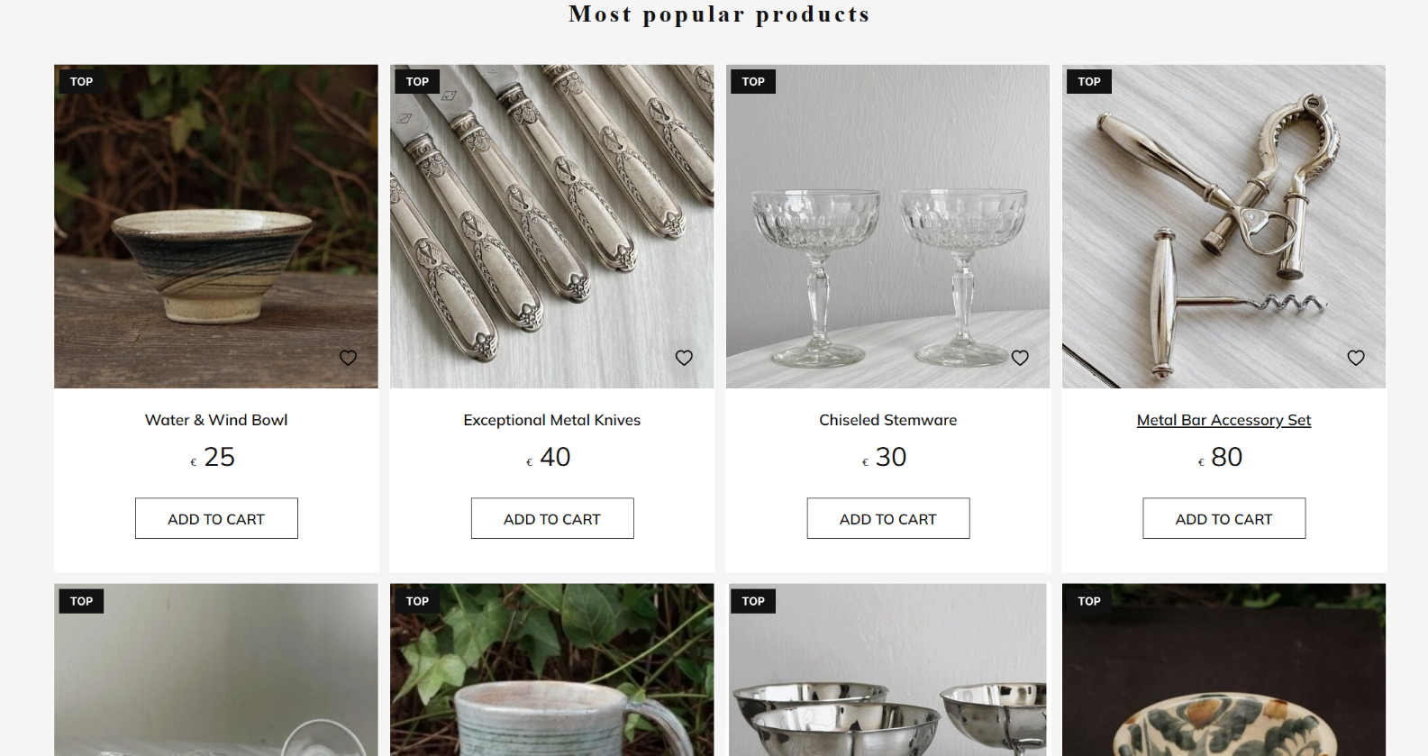Most Popular Products:
* 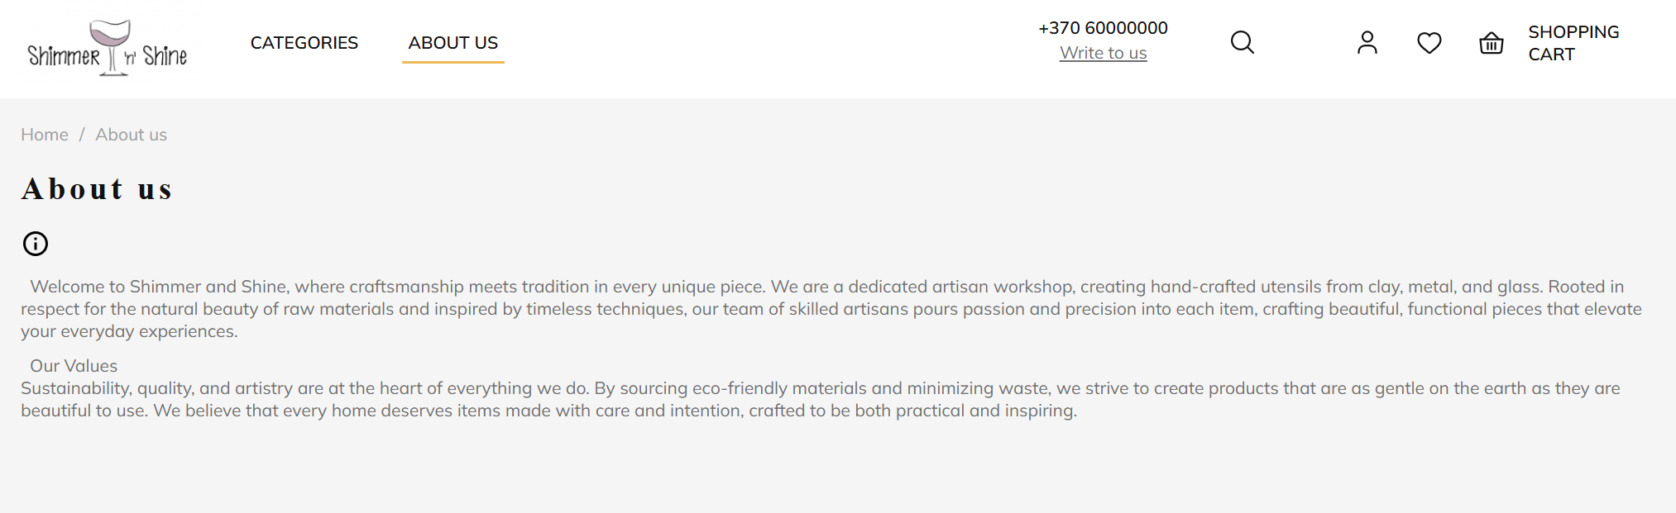About us page:
* 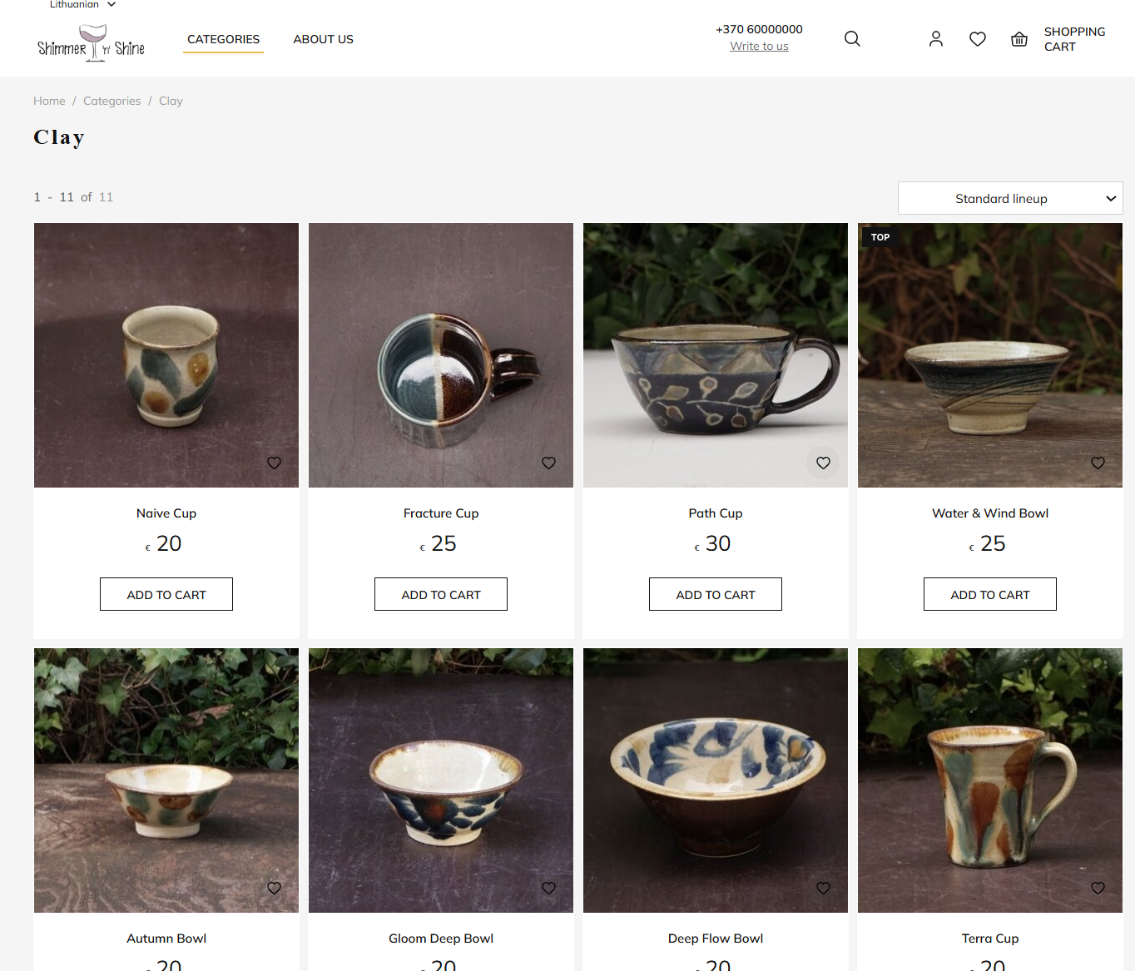Products in the category:
* Login

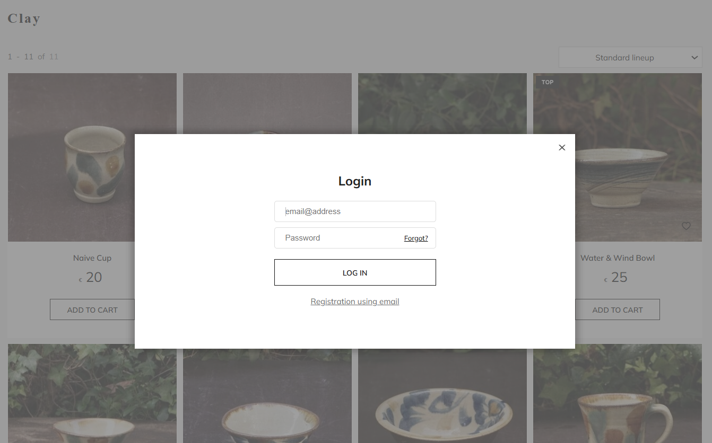

* Registration

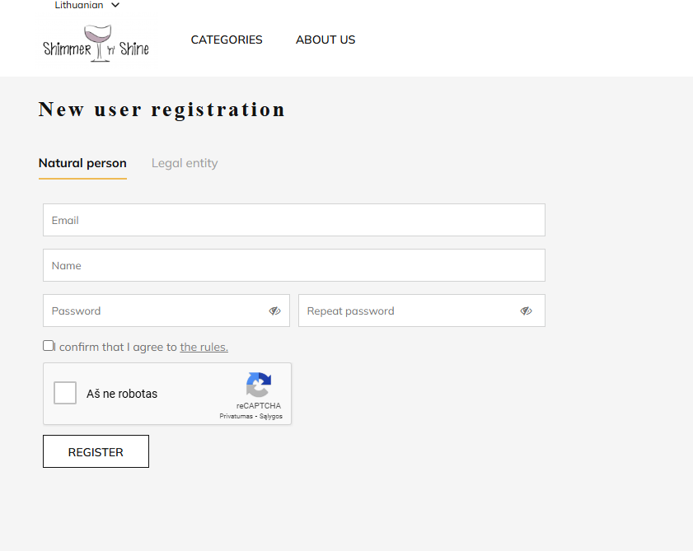

* 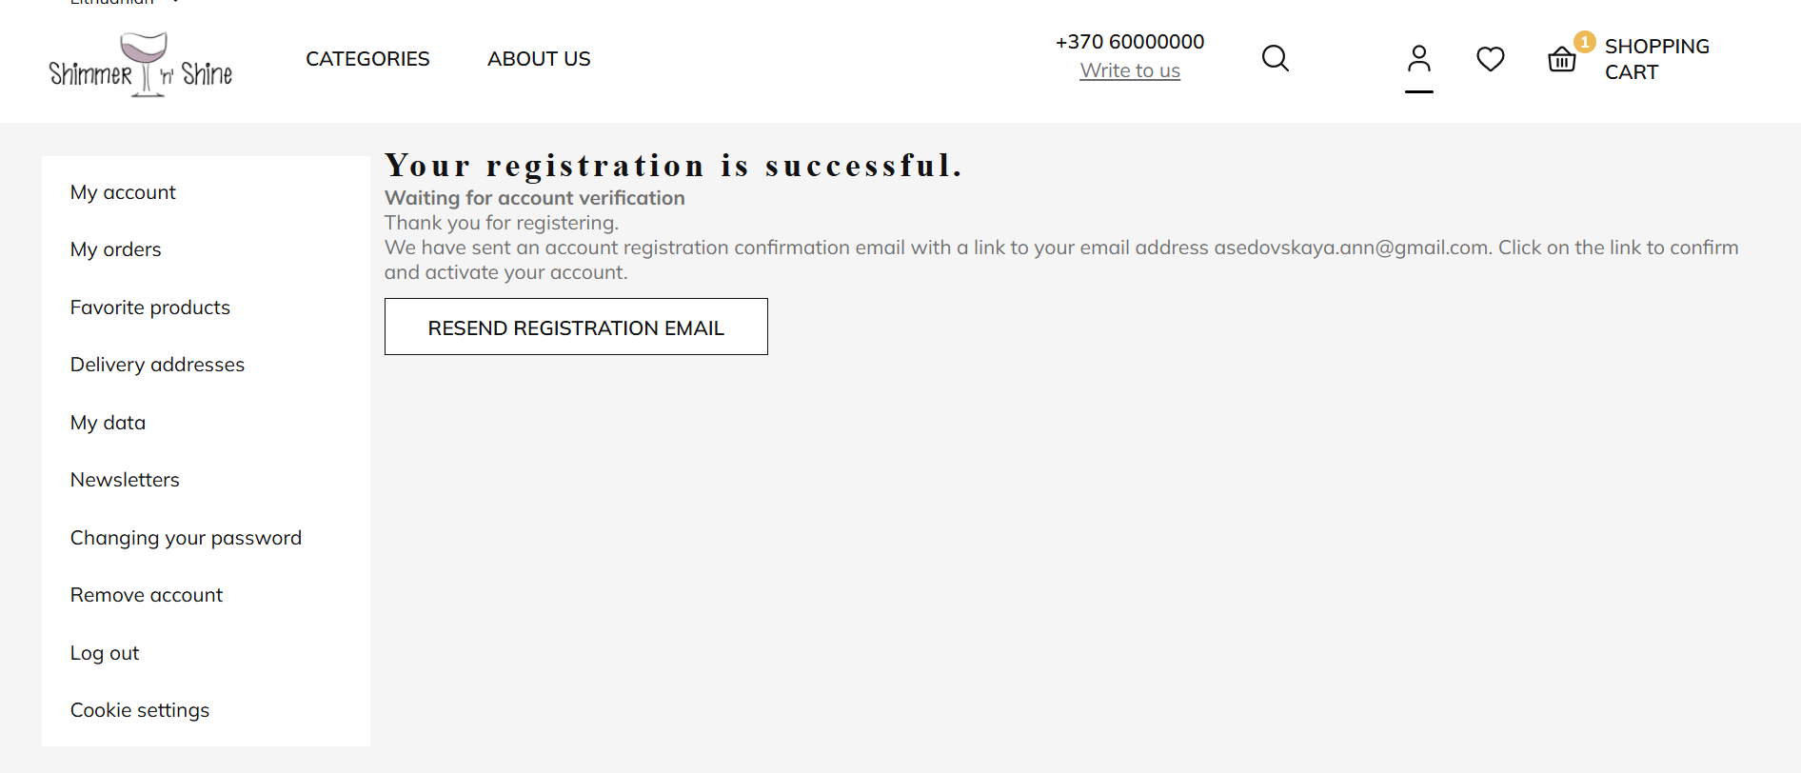Confirmation of the registration:
* 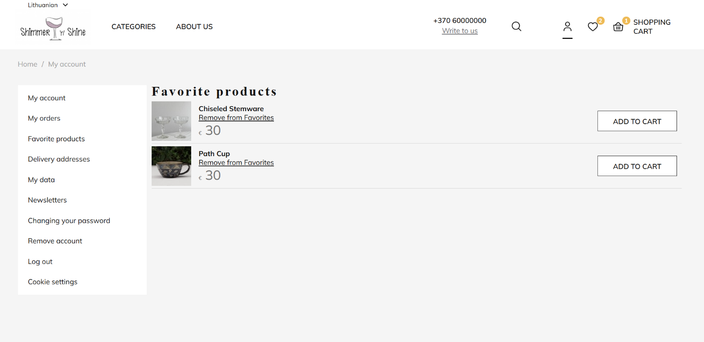Add product to favourites and remove:
* 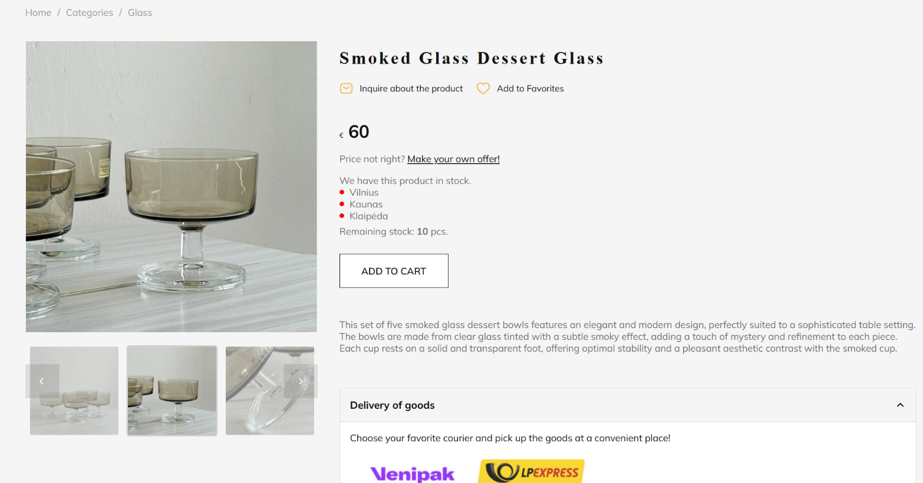Observe items price, description, availability information about different storages, price, types of shipping and payment and users reviews:

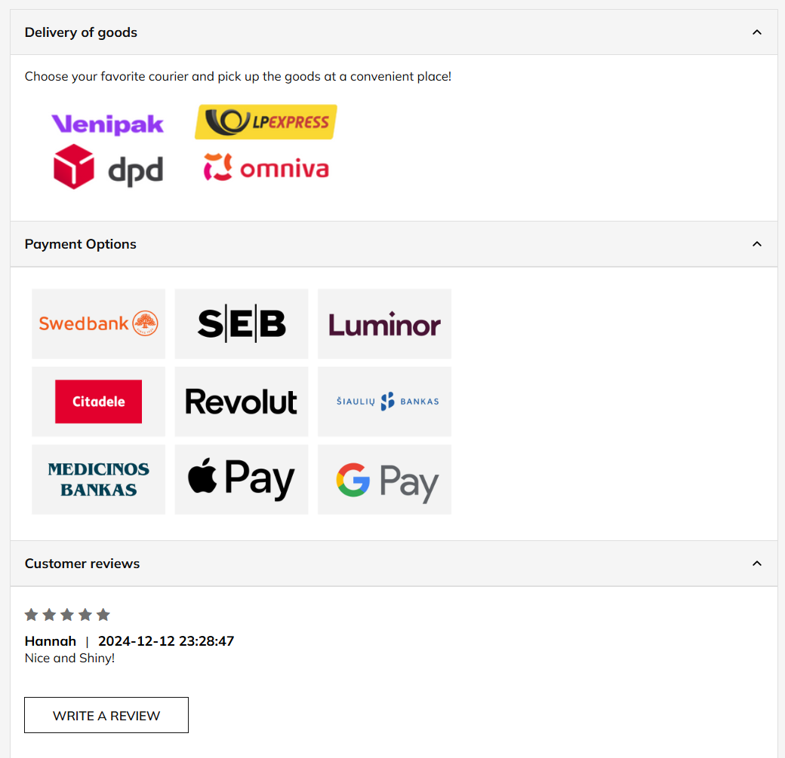#

* Adding product to the cart:

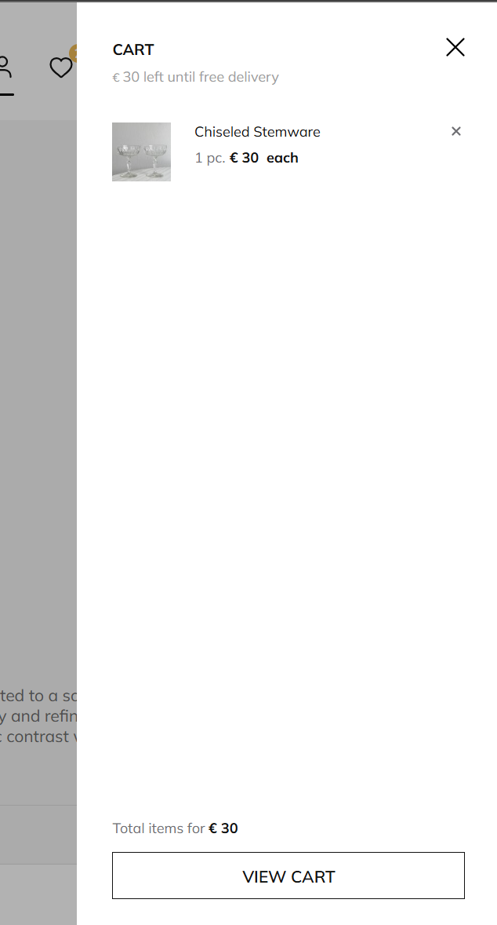

* 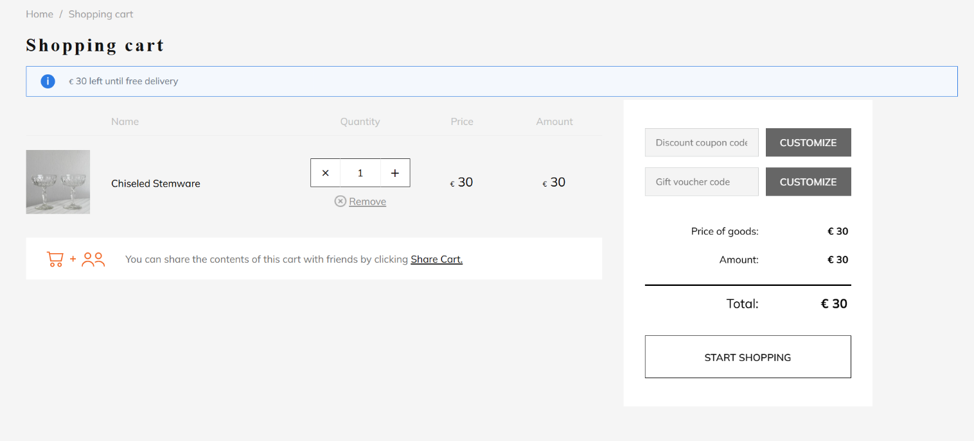Observe Cart:
* 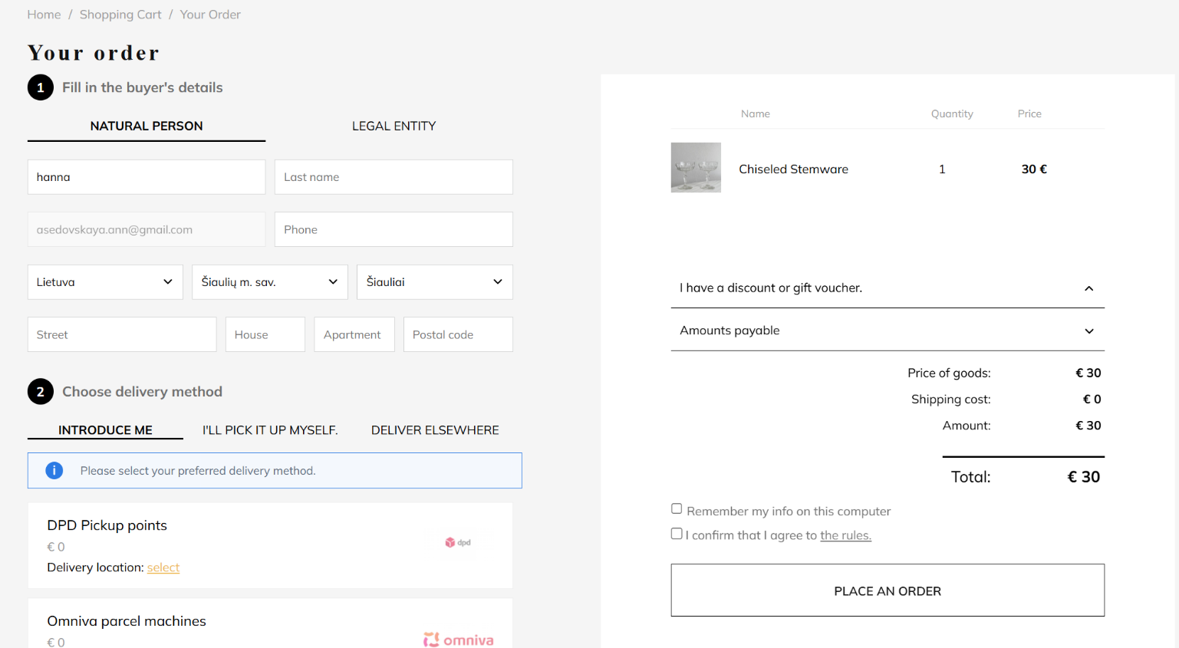Filling information for the order:
* Possibility to choose delivery type:

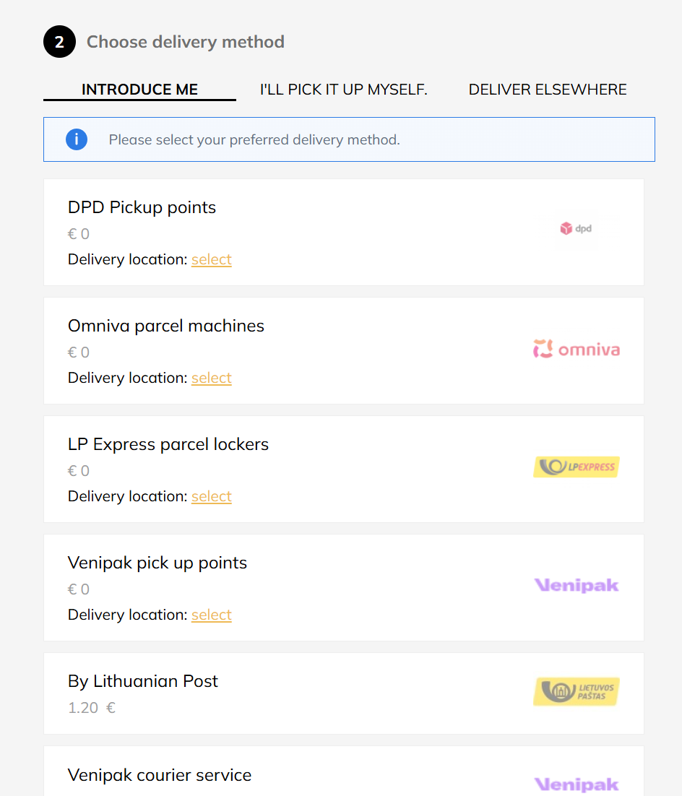

* 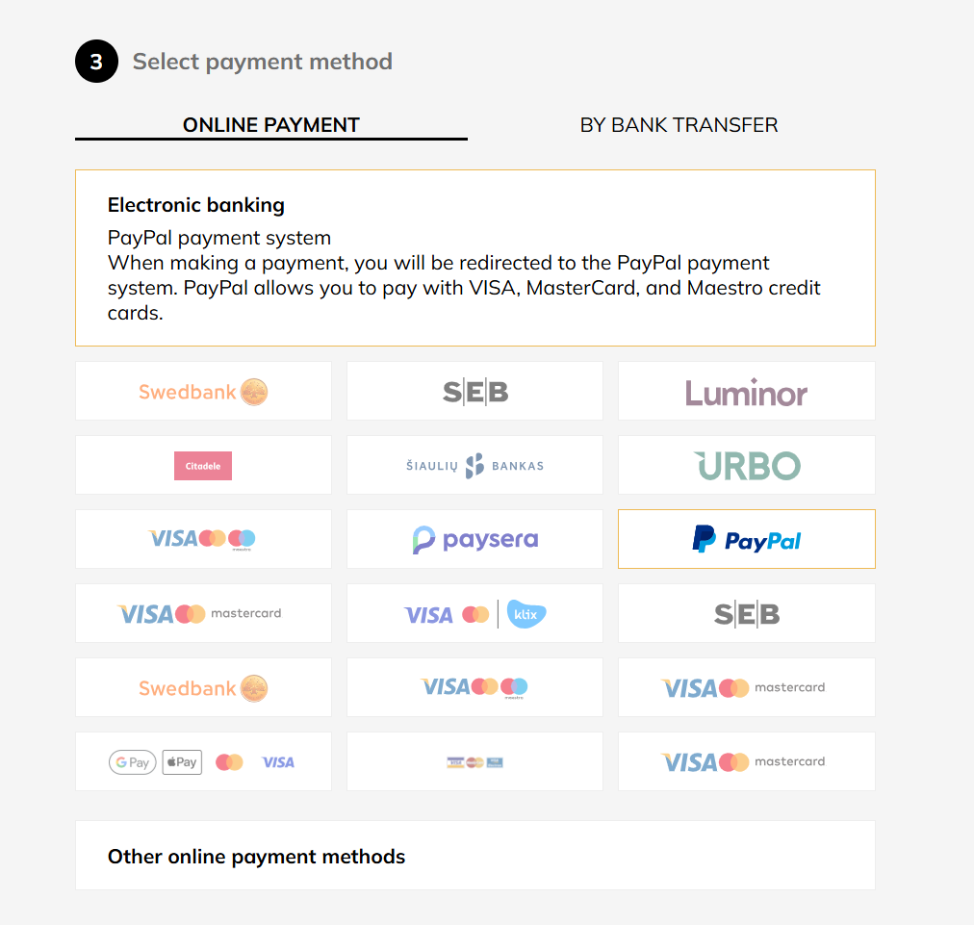Different types of payment including paypal
* 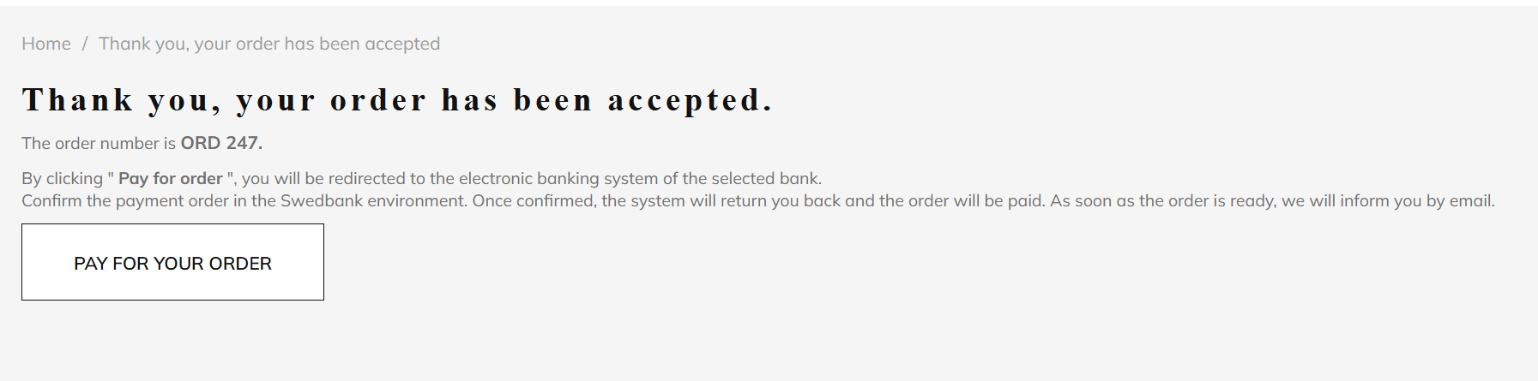Order Acceptance:
* Receive invoice:

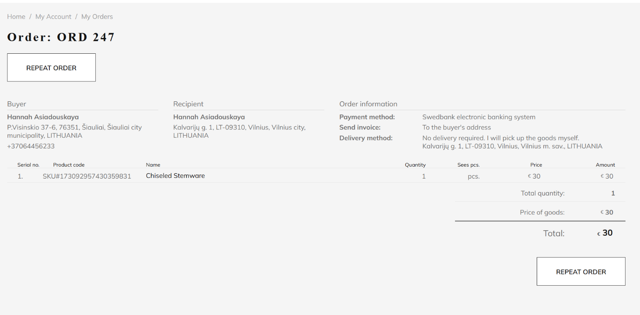

* All of this functionality with easy to follow interface:

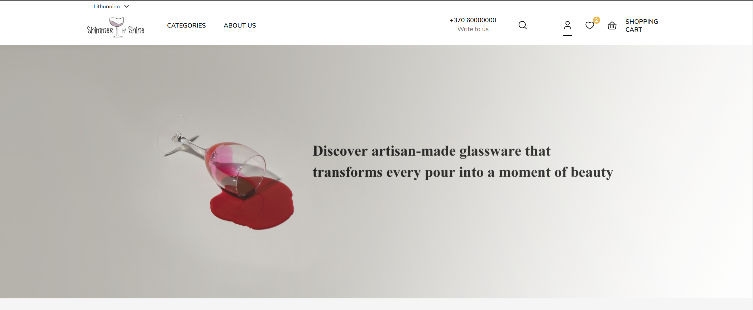

# Modelling of the workflow

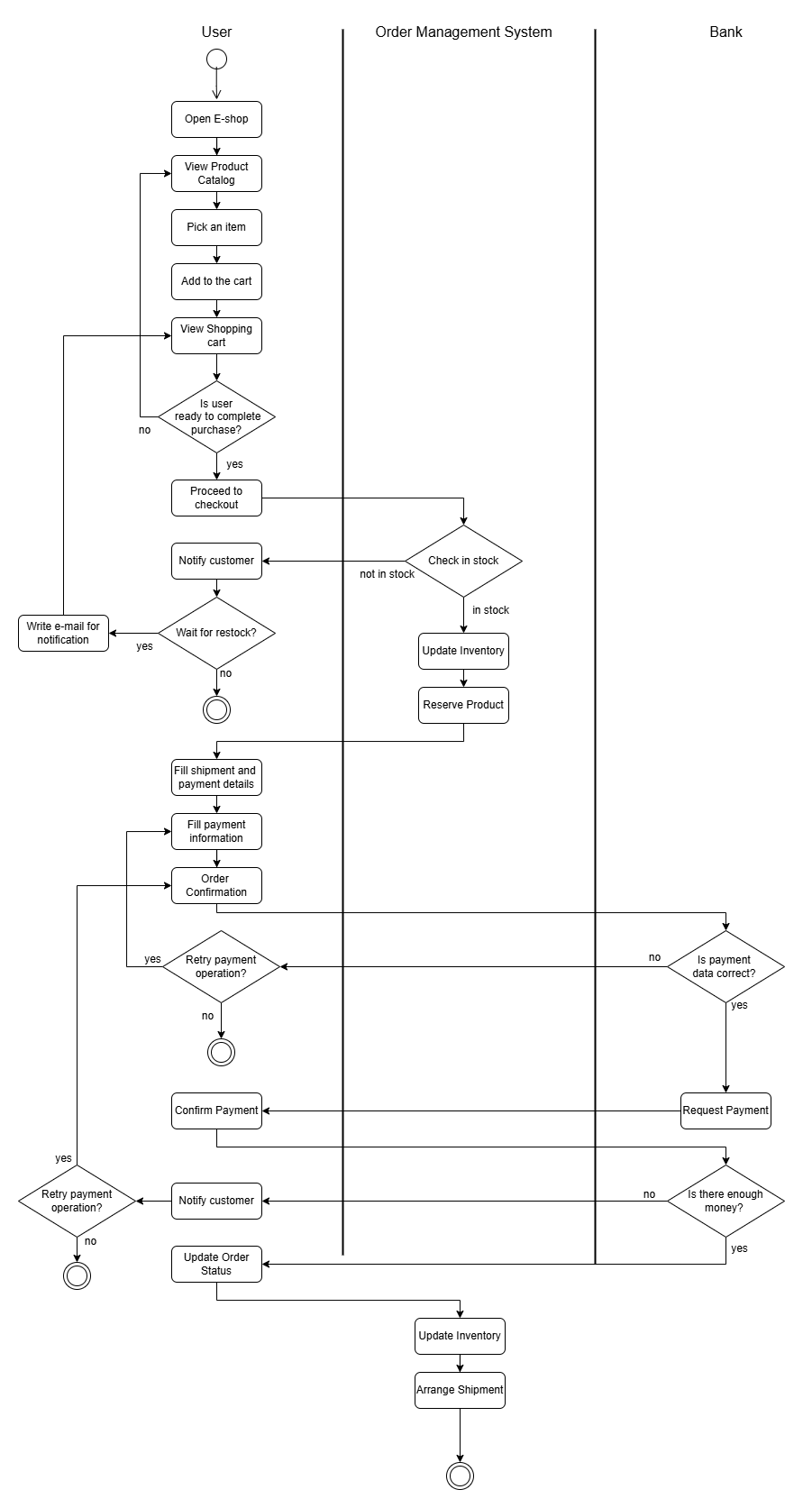Activity diagram of the business process of ordering of the product, making order and payment:

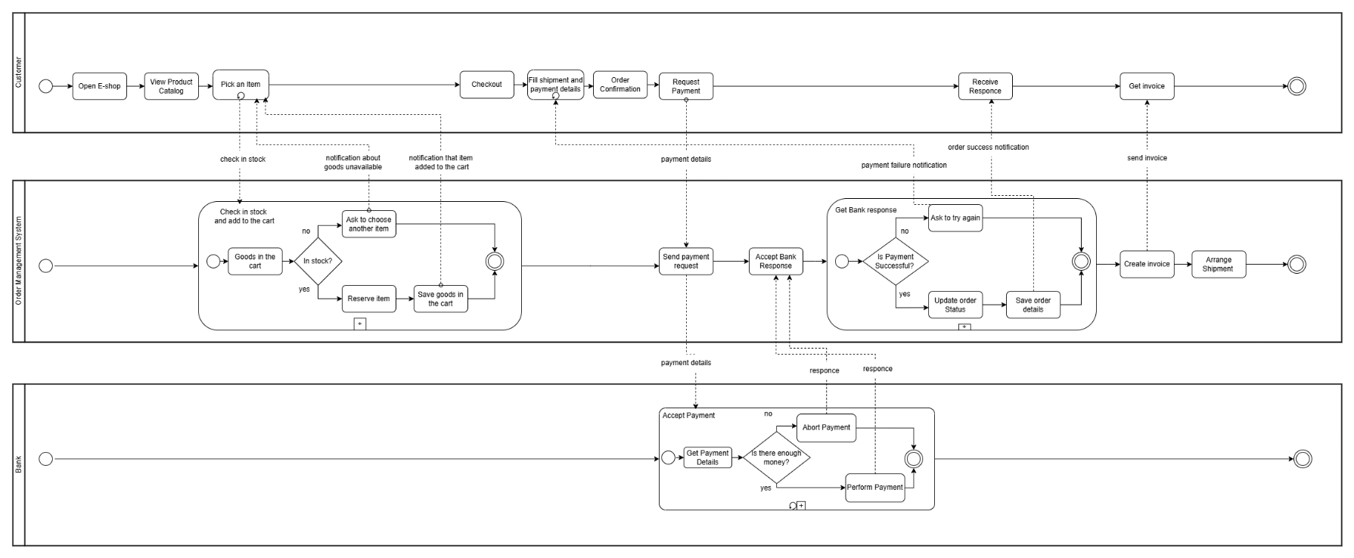Choreography:

Orchestration:

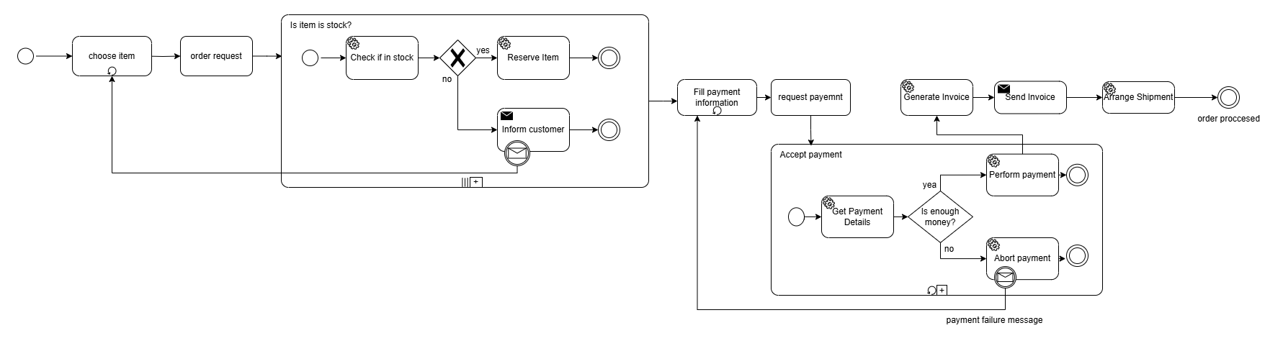

# Conclusion

In conclusion, the creation and launch of an e-shop is a multifaceted project that reflects the growing importance of digital presence in today’s market. By systematically addressing the outlined tasks - from conceptual design to the configuration of payment, shipping, and customer feedback mechanisms - the project not only ensures a functional and user-friendly platform but also aligns with modern business practices. Successful execution will provide a strong foundation for engaging customers, streamlining operations, and fostering sustainable growth in the competitive online marketplace.

# Literature

[[Business Process Modeling Techniques Explained with Example Diagrams (creately.com)](https://creately.com/blog/bpm/business-process-modeling-techniques/#uml)](https://creately.com/blog/bpm/business-process-modeling-techniques/)

[BPMN 2.0 examples non-normative document](https://www.omg.org/cgi-bin/doc?dtc/10-06-02)

[Manual for Verskis.lt](https://www.verskis.lt/pagalba)